Sreenidhi institute of science and technology
(An Autonomous Institution approved by UGC and affiliated to JNTUH)
(Accredited by NAAC with ‘A” Grade, Accredited by NBA of AICTE and
Recipient of World Bank under TEQIP-I and II)
Yamnampet, Ghatkesar Mandal, Hyderabad - 501 301.

COURSE FILE

FOR

DISCRETE MATHEMATICS

FOR

B. Tech. II year - I Semester
CSE



DEPARTMENT OF
Computer Science & Engineering
SEPTEMBER, 2023

Syllabus for B.Tech. II year I Semester
Computer Science and Engineering
DISCRETE MATHEMATICS

Code: 9F303 L T P/D C
2 0 0 2

Prerequisites: Mathematics- I and II
Course Objectives:
1. Define the syntax and semantics of propositional logic.
2. Translate statements from a natural language into its symbolic structures in logic.
3. Prove elementary properties of modular arithmetic and explain their applications in
Computer Science, for example, in cryptography and hashing algorithms.
4. Apply the notion of relations on some finite structures, like strings and databases.
5. Analyze algorithms using the concept of functions and function complexity.
6. Apply graph theory models of data structures and state machines to solve problems of connectivity and constraint satisfaction, for example, scheduling.

Course Outcomes:
1. To evaluate elementary mathematical arguments and identify fallacious reasoning (not just fallacious conclusions).
2. To reason about arguments represented in Predicate logic.
3. Perform operations on discrete structures such as sets, functions, relations, and sequences.
4.Solve discrete mathematics problems that involve: computing permutations and combinations of a set.
5. Analyze and deduce problems involving recurrence relations and generating functions.
6. Apply graph theory models of data structures and state machines to solve problems of connectivity and constraint satisfaction, for example, scheduling.

UNIT – I
Propositional Logic: Statement and notations, Connectives, Well formed Formulas, Truth Tables, Tautology, Equivalence, Implication, Rules of inference, Arguments, Proof by contradiction, Conditional Proof Normal forms, Automatic theorem proving.
Objective: student will be able to understand statements, ,their truth value, constructing truth tables and will be able to prove them using different laws such as associative and commutative etc…

UNIT-II
First order logic: Predicates, Quantifiers, Free and Bound variables, Rules of inference, Consistency, Automatic Theorem Proving.
Objective: student will be able to use universal and existential quantifiers to describe predicates and effectively use automatic theorem proving.

UNIT – III
Relations: Properties of Binary Relations, Equivalence, transitive closure, Compatibility & Partial Ordering Relations, Hasse Diagrams, Lattice and its properties.
Algebraic structures: Algebraic systems, Examples and general properties, Semi groups and Monoids. Groups, Subgroups, Homomorphisms, Isomorphisms
Objective: student will be able to learn different relations and their properties. use of different algebraic structures and their use in mathematics.

UNIT –IV
Elementary Combinatorics:
Basics of counting, Combinations & Permutations with and without repetitions, Constrained repetitions. Binomial coefficients, Binomial and Multinomial theorems, Euler function, Derangemants, Principle of inclusion and exclusion, Pigeon hole principle and its applications.
Objective: student will be able to apply permutations and combinations to solve problems. use of pigeonhole principle and inclusion exclusion principles to solve problems.

UNIT V
Recurrence relations: Generating functions. Function of sequences, Calculating the coefficient of generating functions. Recurrence relations, Solving recurrence relations by substitution and generating functions. Characteristic roots. Solution of Inhomogeneous recurrence relations.
Objective: student will learn to solve various recurrence relations by using different techniques.

Unit VI
Graph Theory: Basic concepts, Representation of Graph, DFS, BFS, Spanning trees, Planar graphs, coloring, Isomorphism and subgraphs, Multi graphs and Euler Circuits, Hamiltonian graphs, Chromatic numbers, connectivity, cut vertices, cut edges, Matching and coverings, independent sets.
Objective: student will learn the basics of graph theory, different ways of traversing the graph and different types of graphs and circuits which has important applications in further subjects.

TEXT BOOKS :
1. Discrete Mathematics for Computer Scientists & Mathematicians, J.L. Mott, A. Kandel, T.P. Baker, PHI.
2. Discrete mathematics with applications to computer science, J.P.Tremblay and R.Manohar, TMH
3. Elements of Discrete mathematics – A computer Oriented Approach- C L Liu, D P Mohapatra. Third Edition, Tata MacGraw Hill.

REFERENCES:
- Discrete and Combinational Mathematics- An Applied Introduction-5th Edition – Ralph. P.Grimaldi.Pearson Education.
- Discrete Mathematics and its Applications, Kenneth H. Rosen, Fifth Edition.TMH.
3. Discrete Mathematical structures Theory and application-Malik & Sen, Cengage.
Lecture Schedule

UNIT NUMBER | Lecture No. | Topic
I | 1 | Introduction, Statements and connectives
 | 2 | Truth Tables, Tautological implications
 | 3-6 | Equivalences, Implications, Normal forms
 | 7 | Conditional Proof
 | 8-10  11-12 | Rules of inference, Arguments,  Proof by contradiction,
II | 13-14 | Predicates, Quantifiers
 | 15 | Free and Bound Variables
 | 16 | Rules of inference, Consistency,
 | 17-18 | Automatic Theorem Proving
III | 19 | Properties of Binary Relations
 | 20-21 | Compatibility & Equivalence Relations
 | 22 | Partial Ordering relations
 | 23 | Hasse diagrams
 | 24-25 | transitive closure,
 | 26 | Lattice and its properties
 | 27 | Algebraic systems, Examples and general properties
 | 28-29 | Semi groups & Monoids
 | 30-31 | Groups & Sub groups
 | 32 | Homomorphism & Isomorphism
IV | 33-35 | Basics of counting, combinations & permutations
 | 36-38 | Binomial and Multinomial theorems, Principle of inclusion - exclusion
 | 39 | Pigeon hole principle and its applications.
V | 40-42 | Generating functions, Calculating coefficients of generating functions
 | 43-45 | Recurrence relations, Solving by Substitution and Generating functions
 | 46-49 | Characteristic roots, Solution of inhomogeneous recurrence relations
VI | 50-52 | Graph theory, Basic concepts,
 | 53 | Representation of graph
 | 54-56 | Spanning trees, DFS, BFS
 | 57-58 | Planar Graphs, Matchings and coverings.
 | 59-60 | Isomorphism and sub graphs
 | 61-62 | Multi graphs and Euler circuits.
 | 63-64 | Hamiltonian graphs .
 | 65-67 | Chromatic numbers, connectivity, matchings and coverings.

UNITS – I &II (Propositional and First order logic)

Short answer and long answer questions

- Explain the law of ‘excluded middle’ and the‘law of contradiction’.

- What is ‘well formed formula’?. Explain with asuitable example.

- Construct truth tables for the following statement formulae.
  - ∼(∼P ∧ ∼Q)
  - (P∧Q) ∨ (∼P∧Q) ∨ (P∧ ∼Q) ∨ (∼P∧ ∼Q)

- a) Show that ((P∨Q) ∨ ∼P) is a tautology.
b) Show that (∼(P∨Q) ∨ ( ∼ P∧Q ) ∨ P) is a tautology
c) What is the contra positive equivalence of (P→ ∼Q).

- Write the truth table for (P→Q) ?

- Write the truth table for
  - (((P→Q) ∧P) → Q)
  - ((P∧Q)∨(∼P∧Q))

- Given P = Q = T & R = S = F find the truth value of
  - (P↔R) ∧ (∼Q→S)
  - (P∨(Q→ (R∧∼P))) ↔ (Q∨∼S)
where T = true and F= false.

- Define ‘tautology’ and ‘contradiction’ . Give an example for both .

- What is ‘logical equivalence’?

- What is ‘logical implication’?

- Show that P→(Q→R) ⇔ (P∧Q)→R

- State the following laws:
  - Idempotent laws
  - Associative laws
  - Commutative laws
  - Distributive laws
  - Absorption laws
  - De Morgan’s laws

- What is the principle of duality ?

- Find the dual of
  - (P∨Q) ∧R
  - (P∧Q) ∨ T
  - ∼(P∨Q) ∧ (P∨∼(Q∧∼S))

- When does a statement A tautologically imply a statement B?

- Prove that if { H_{1,} H_{2,} H₃, ------- H_{m} and P } imply Q, then{H_{1,} H_{2,} H₃, ------- H_{m} } imply (P→Q).

- When is a connective (or set of connectives) functionally complete? Give examples.

- Write down the truth table for P ↑ Q and P ↓ Q and show that they are duals of each other.

- Show that the set {↑} is a minimal functionally complete set.

- Define a conjunctive Normal form.

- Define disjunctive Normal form.

- What is a principal disjunctive Normal form?

- What is a min term? And what is its main characteristic feature?

- What is principal conjunctive Normal form?

- Obtain the principal disjunctive normal forms of:
  - ∼P∧Q
  - (P∧Q) ∨ (∼P∧R) ∨ (Q∧R)
  - P→ ((P→Q) ∧ ∼(∼Q ∨ ∼P))

- Obtain the principal conjunctive normal forms of:
  - (∼P→R) ∧ (Q↔P)
  - Q∧ (P ∨ ∼Q)
  - (Q→P) ∧ (∼P∧Q)

- Demonstrate that R is a valid inference from the premise P→Q, Q→R, P.

- Show that R→S can be derived from the premises P→(Q→S), ∼R∨P, and Q.

- State the rule CP or the rule of Condition Proof.

- State the rules of Antecedent and rules of Consequent used for automatic theorem proving.

- By using the rules of automatic theorem proving show the following:
  - P∨Q follows from P
  - P ⇒ (∼P→Q)
  - R ⇒ P∨( ∼P∨ Q)

Questions from old papers of JNTU :

- Using predicate calculus show
  - (x) (H(x) →M(x)) ∧ H(s) ⇒ M(s)
  - (x) (P(x) ∨Q(x)) ⇒ (x) P(x) ∨ (∃x) Q(x)

- Show
  - (∃x) P(x) → (x) Q(x) ⇒ (x) (P(x) → Q(x))
  - (x) (P(x) →Q(x)) ⇒ (x) P(x) → (x) Q(x)

- Show the following by constructing derivations:
(∃x) P(x) → (x) ((P(x) ∨ Q(x)) → R(x)), (∃x) P(x), (∃x) Q(x)
⇒ (∃x) (∃y) (R(x) ∧ R(y))

- Are the following conclusions valid from the premises given? Justiy your answer.
  - (x) (P(x) → Q(x)), (∃y) P(y) C : (∃z) Q(z)
  - ∃(x) (P(x) ∧ Q(x)) C : (x) P(x)
  - (x) ( P(x) → Q(x)), ∼Q(a) C : (x) ∼P(x)

- Show that ( ∼P ∧ (∼Q∧R)) ∨ (Q∧R) ∨ (P∧R) ⇔ R

- Obtain the principal conjunctive normal form of the formula S given by
(∼P→ R) ∧ (Q→P).

- Symbolize the expression “ All the world loves a lover” and write the
Predicate.

- Symbolize the statement “All men are Giants”.

- Show that ((P∨ Q) ∧ ∼(∼P∧(∼Q∨∼R))) ∨ (∼P∧∼Q) ∨ (∼P∧∼R) is a tautology.

- With reference to automatic theorem proving, show that S∨R is tautologically implied by (P∨ Q)∧(P→R) )∧(Q→S)

- Show that R→S can be derived from the premises P→(Q→S), ∼R∨P and Q.

- Show the following premises are inconsistent.
    - If Jack misses many classes through illness, then he fails high school.
    - If Jack fails high school, then he is uneducated .
    - If Jack reads lot of books, then he is not uneducated.
    - Jack misses many classes through illness and reads lot of books’

- Construct the truth table for (P→Q) ∧(Q→P)

- Show that R∨S follows logically from premises C∨D, C∨D→ ∼H,
∼H→ (A∧∼B), (A∧∼B)→ (R∨S).

- a. Define Universal Specification and Existentian Specification.
- Define Universal generalization and Existential Generalization.

- a. Symbolize the following statements.All men are giants.
X is a man. therefore X is a gaint.

b. Construct the truth table for the following:
∼(P∧Q) ↔ (∼P ∨ ∼Q)

- Obtain the principal disjunctive and conjunctive normal forms of the following formula: P∨(∼P→(Q∨(∼Q→R))).

49. Demonstrate the following implications:
    - (x) (P(x) → Q(x)),
    - (x) (Q(x) → R(x)) ⇒ P(x) → R(x)

50. Show that S∪R is tautologically implied by
(P∨Q) ∧ (P→R) ∧ (Q→S).

51. Prove the following argument, using symbolic logic.
Babies are illogical
No body is despised who can manage a crocodile
Illogical persons are despised
--------------------------------------------
∴ Babies can not manage crocodiles

52. Prove the following argument, using symbolic logic
Every living thing is plant or animal.
. David’s dog is alive and it is not a plant.
All animals have hearts.
∴ David’s dog has a heart

53. Prove the following argument, using symbolic logic
If cliffton does not live in france, then he does not speak french
Cliffton does not drive a datsun
If cliffton lives in France or he rides a bicycle
Either cliffton speaks French or he drives a Datsun
∴ Cliffton rides a Bicycle

UNIT – III (Sets and Relatios)
Short answer and long answer questions
- Define a Binary relation for sets

- Define the following for a binary relation:
  - Reflexive
  - Symmetric
  - Transitive
  - Anti-symmetric
  - Irreflexive
  - Asymmetric
- Define an equivalence relation. Give two examples.
- If an equivalence relation R exists between members of a set S. How will you be able to use this information to partition S?
- Define the relation matrix between two sets x and y.
- Define partial ordering relation on a set.
- Distinguish between partial and total ordering.
- A set X = {1,3,6,12,24,36} If we say x ≤ y if x divides y. Draw the Hasse diagram for {x, ≤}.Show that {X;≤} is a meet semi lattice but not a join semi lattice.

- Let A = {a,b,c}; If we use the symbol ≤ to define the set inclusion relation, draw the Hasse diagram for the power set of A i.e. P(A).Show that {P(A); ≤} is a distributive lattice.
- Define the various mappings possible which take elements of a set A to elements of set B. when is a mapping well defined?

- Define a lattice, and illustrate your definition with examples.

- In a lattice, show that a∧b=a ⇔ a∨b=b
- Define compatibility relation .Give two examples.

- Show that the relation ‘divides” is a partial order on a set of positive integers.

- Show that the relation R defined over set of all integers as a R b ⇔ b = a^{r}
for some positive integer r is a partial order.

- Show that the relation R = { (x , y)⏐ x-y is an integer }is an equivalence relation.

- What is compatibility relation?. Exlplain with an example.

- What is a boolean algebra?. Show that Power set of a finite set is a boolean algebra.

Questions from old papers of JNTU
- Define partially ordered sets; Let X = {2,3,6,12,18,36,48,56}, Define a relation “R” as follows; nRm means n divides m. Draw the Hasse diagram of ( X ; R).

- a. Is the posit A = {2,3,6,12,24,36,72} under the relation of divisibility a lattice? Justify your answer.
  - Determine the greatest and least elements, if they exist, of the posit A = {x | x is a real number and 0 < x < 1} with the usual partial order ≤.

- Let X = {36,24,12,6,3,2} and the relation ≤ be such that x ≤ y if x divides y. Draw the Hasse diagram of [ X, ≤ ].

- In a lattice, show that a∧b=a ⇔ a∨b=b

- Define the dual of a statement in a lattice L. Why dos the principle apply to L?

- Show that there are only five distinct Hasse diagrams for posets that contain three elements.

- Show that the set of positive integers N is a lattice with respect to the relation “divides”.

- Prove that the function f : A→B has an inverse iff f is bijective.
- Define the term “lattice”, clearly stating the axioms.

- Let C be a collection of sets which are closed under intersection and union. Verify whether (C,∪,∩) is a lattice.

- Show that the relation of congruence modulo ‘m’ has m distinct equivalence classes.
- Show that the relation R on the set Z of all integers is an equivalence relation. where R is defined by (a , b) ∈ R iff a - b is an integral multiple of 2. Find the equivalence classes determined by R.

- Let A be a given finite set and P(A) is its power set. Draw Hasse diagram of [P(A) ; ⊆] for i) A ={ a } ii) A ={ a , b } iii) A={ a, b ,c }.

(Algebraic structures) Short and long answer Questions.

- Define Semi group, Monoid , Group and Abelian group. Give an example for each case.

- Show that set of all strings is a monoid under the operation ‘concatenation of strings’. Is it a Group? Justify your answer.

- Let S be a finite set. Let F(s) be the collection of all functions f : S→S under the operation of composition of functions. Show that F(S) is a monoid but not a group.

- Show that set of all rational numbers ‘x’ such that 0 ≤ x ≤ 1 with respect to multiplication, is a monoid but not a group.

- Show that the set of all positive rational numbers forms an abelian group under the composition defined by a * b = (ab) / 2.

- Show that the set G = {0,1,2,3,4,5}is a group with respect to addition modulo 6.

- Show that the set G = {1,2,3,4,5,6} is a group with respect to multiplication modulo 7.

- Define Sub group. Give an example. What is the difference between a semi group and a sub group ?.

- Let H be a non empty subset of a group (G, * ) , Show that
H is a sub group of G ⇔ a* b⁻¹ ∈ H for all a, b∈ H
- State Lagrange’s Theorem. Prove that Union of two sub groups of a group is not a subgroup.

- Prove that Intersection of two sub groups of a group is a subgroup.

- Prove that Union of two sub groups of a group is a subgroup⇔one sub group is contained in the other.

- Define Group homomorphism. Give an example. When do you say two groups are Isomorphic.

- If f :G → G¹ is a group isomorphism. Prove the following
a) f(e) = e¹ a) f (a⁻¹ ) = {f(a)}⁻¹ c) f is an equivalence relation.

- Let G be a reduced residue system modulo 15 say
G = { 1,2,4,7,8,11,13,14} ( i.e., the set of integers between 1 and 15 which are co prime to 15 ).Show that G is a group under multiplication modulo15.

UNIT – IV & V (Elementary Combinatorics & Recurrence relations)

Short and long answer Questions + JNTU questions

- How many six letter words can be made from the letters {S, N, I, S, T } ?

- Consider all six digit numbers not beginning with zero, how many numbers are there?

- Five people A,B,C,D,E make plane reservations but all need not show up how many possibilities are there?

- What is the Pascal’s triangle?

- Prove the Binomial theorem by using combinatoric arguments, for integer index.

- In how many ways can seven cricket balls be distributed among and four children so that each child receives at least one ball?

- (Lewis Caroll) In a very hotly contested battle among 100 combatants, 80 lost an arm, 85 lost a leg, 70 lost an eye, 75 lost an ear. How many (at least) lost all four?

- A coin is tossed 10 times. how many possible out comes are there ?

- Explain about enumerating permutations with constrained repetitions.

- Write down a recurrence relation for the n^{th} term of a Fibonacci series and solve it to find and expression for the n^{th} term?
- Solve the difference equation y_{n} – 3y_{n-1} + 3y_{n-2} – y_{n-3} = 0 subject to y₀ = 0, y₃ = 1, y₅ = 2.

- Find the general solution of x_{n} – 3x_{n-1} – 10x_{n-2} = 0, x₀ = 1 and x₂ =2.

- Find the general solution of
  - x_{n+2} – 4x_{n+1} + 4x_{n} = 2^{n} (n≥0)
  - x_{n+1} + 2x_{n} = 3+4^{n}; x₀ = 2

- Solve the recurrence relation S(k) – 0.25 S(k-1) = 0 , S(0)=6

- Solve the difference equation a_{n} – 9a_{n-1} + 26 a_{n-2} – 24a_{n-3} = 0 for n ≥ 3

- Solve the recurrence relation a_{n} – 3a_{n-1} = n+2

- Solve the recurrence relation a_{n} – 3a_{n-1} = (n+2) 3^{n}

- Solve the recurrence relation a_{n} = 2a_{n/2} + (n-1)
- Solve the recurrence relation a_{n} = a_{n-1} + n where a₀ = 2, by substitution method.

- Solve the recurrence relation a_{n} = a_{n-1} + 2n +1 where a₀ = 1, by substitution method.

- Solve the recurrence relation a_{n} = a_{n-1} + 3^{n} where a₀ = 1, by substitution method

- Solve the recurrence relation a_{n} = a_{n-1} + 3n² + 3n + 1 where a₀ = 1, by substitution method

- Solve the a_{n} – 6a_{n-1} + 12 a_{n-2} – 8a_{n-3} = 0 by generating functions.

- a) Solve the a_{n} – 7a_{n-1} + 10 a_{n-2} = 0 (n ≥ 2) , by generating functions.
b) Find a generating function to count the number of integral solutions to
e₁ + e₂ + e₃ =10 if for each i, 0 ≤ e_{i}

26. Find a generating function for a_{r} = The number of ways of distributing r similar balls into n numbered boxes where each box is non empty.

27. Find the coefficient of X¹⁶ in (1 + X⁴ + X⁸ )¹⁰

28. In (1 + X⁵ + X⁹ )¹⁰ find
a) the coefficient of X²³
a) the coefficient of X³²

29. Find the coefficient of X²⁰ in ( X³ + X⁴ + X⁵ …)⁵

- Give Combinatorial proof for the following Identities
a) C(n ,r) C(r , k) = C(n , k) C(n-k , r-k)
b) C(n , r) = n C(n-1 , r-1)
  - C(n , r) = C(n-1 , r) + C(n-1 , r-1)
  - P(n , r) = n P(n-1 , r-1)
  - C(n,0) + C(n,1) + C(n,2) +…. C(n,n) = 2^{n}

- State and prove multinomial theorem.

- Using Binomial theorem, determine the coefficient of x³ y⁷ in (x+y)¹⁰

- Using Binomial theorem, determinethe coefficient of x³ y⁷ in (2x-9y)¹⁰

- Using multinomial theorem, determine the coefficient of x₁² x₃ x₄³ x₅⁴ in (x₁+x₂+x₃+x₄+x₅)¹⁰

- How many 10 digit binary numbers are there with exactly six 1’s ?

- In how many ways 10 persons can be seated in a row so that a certain pair of them are not next to each other?

- How many integers between 10⁵ and 10⁶ have no digits other than 0,2,5,8 ?

- Enumerate the number of ways of placing 20 similar balls in to 5 numbered boxes where each box is non empty?

- How many non negative integer solutions are there to x₁+x₂+x₃+x₄+x₅=20 where x₁≥3, x₂≥2, x₃≥4, x₄≥6, x₅≥0.

- Find the number of positive integers which are less than 91 and relatively prime to 91.

- In how many ways we can place 5 different letters in 5 addressed envelopes, so that no letter is placed in the correct envelope.

- In a group of 100 persons,50 persons can speak Telugu,40 persons can speak Hindi and 30 persons can speak both languages.
  - How many persons can speak at least one language?
  - How many persons can speak exactly one language?
  - How many persons can speak none of the two languages?
  - How many persons can speak Hindi but not Telugu?
  - How many persons can speak Telugu but not Hindi?

- In EAMCET examination 100 students appeared from a college.40 students failed in Mathematics,30 students failed in Physics, 25 students failed in Chemistry, 20 students failed in Mathematics and Physics,15 students failed in Physics and Chemistry, 10 students failed in Chemistry and Mathematics and 5 students failed in all three subjects.
a) How many students failed in at least one subject?
    - How many students failed in none of the 3 subjects?
    - How many students failed in at least 2subject s?
    - How many students failed in exactly 2 subjects?
    - How many students failed in only one subject ?
    - How many students failed in Physics but not failed in Mathematics .and Chemistry?
    - How many students failed in Physics and Chemistry but not failed in Mathematics?

- In the set {1,2,3,…,1000},How many elements are not divisible by 2 or 3 or 5 ?

- In how many ways can we choose 3 of the numbers from 1 to 100 , so that their sum is divisible by 3.

- How many numbers can be formed using the digits 1,3,4,5,6,8 and 9 if
  - no repetitions are allowed.
  - repetitions are allowed.

UNIT – VI ( GRAPH THEORY )
Short and long answer Questions + JNTU questions

- Define a non directed graph, a directed graph and a multi graph.

- When are two graphs isomorphic? Give examples.

- When is a node u reachable from node v in a given graph?

- Define an adjacency matrix of a graph.

- Define Regular graph, Complete graph and Bipartite graph

- Define a cycle. When is a graph simple?

- What is a bipartite graph?

- Distinguish between the following: (give precise definitions)
  - A trail
  - An Euler trail
  - A tour
  - An Euler tour
  - An Eulerian graph

- Describe the famous “Konigsberg Bridge” problem. Is the problem solvable? Give reasons.

- State and Prove the “First theorem of graph Theory”.
- When is a graph k– regular?

- Define the following terms:
  - A sub graph
  - A spanning sub graph
  - A super graph
  - An edge deleted sub graph
  - A vertex deleted sub graph

- When are two sub graphs “disjoint”? When are they “edge disjoint”?

- Define a Hamilton path of a graph.

- When is a graph Hamiltonian?

- If G is a graph in which the degree of every vertex is at least 2, prove that G must contain a cycle.

- Prove that a connected graph G is Eulerian if and only if the degree of every vertex is even?

- Prove that a connected graph G has an Euler trail if and only if it has at most two odd vertices?

- What is the Chromatic number of a graph?

- What is a tree?

- What is a spanning tree?

- State Cayley’s theorem with regard to spanning trees

- Prove that a graph G is connected if and only if it has a spanning tree.

- State and prove Kruskal’s algorithm.

- State and prove Prim’s algorithm.

- What is a weighted graph?

- Give the Breadth first search algorithm?

- Define the following:
  - A binary tree
  - A forest

- Define chromatic number of a graph. What is the chromatic number of the following graphs?
    - Bipartite graph
    - Complete graph with n vertices
    - Wheel graph with n vertices where n is even
    - Cycle graph with n vertices
    - Tree

- Discuss the following:
  - Binary tree traversal
  - Spanning trees, Minimal spanning trees
  - Kruskal’s algorithm

- State and prove Euler’s formula for Planar graphs?

- Discuss BFS algorithm.

- Discuss DFS algorithm.

- In a connected plane(simple)graph G, with ⏐E⏐ > 1, prove that
a) ⏐E⏐ ≤ 3⏐V⏐- 6 and
  - there is a vertex v of G such that degree(v) ≤ 5.

- Show that a complete graph K_{n} is planar iff n ≤ 4

- Show that a complete bipartite graph K_{m,n} is planar iff m≤ 2 or n ≤ 2.

- Prove that there does not exist a polyhedral graph with exactly seven edges.

- Prove that there does not exist a polyhedral graph with exactly 30 edges and 11 regions.

- State and prove Grinberg’s Theorem.

- Show that, a non directed multigraph has an Euler path if it is connected and has 0 exactly 2 vertices of odd degree.

- How many spanning trees are there in a fully connected graph of order n (i.e. with n vertices)?

- Draw a cycle graph which is isomorphic to its complement.

- Show that there is no planar graph with regions of degree 5,8 and 9 , with exactly one region of degree 9.

- Show that the chromatic number of the tree is 2.
- Suggest a method for determining the total number of spanning trees of a connected graph without actually listing them.

- Is there a graph with degree sequence {1,3,3,5,6,6 }? Justify your answer.

- Draw the graph that has Hamiltonian path but does not have a Hamiltonian Cycle.

- Give some basic rules for constructing Hamiltonian paths and Cycles.

- Prove that for any Polyhedral graph
    - ⏐V ⏐≥ [2 + ⏐R ⏐/ 2 ]
    - ⏐R⏐≥ [2 + ⏐V⏐/ 2 ]
    - 3 ⏐R ⏐ -6 ≥ ⏐E ⏐

- If G is a Polyhedral graph with 12 vertices and 30 edges, Prove that
Degree of each region is 3.

- Suppose a connected planar graph has 20 vertices, each of degree 3. In to how many regions does a representation of this planar graph split the plane.

- Suppose a connected planar graph has 35 regions each of degree 6. In to how many vertices does a representation of this planar graph split the plane.

- State Kuratowski’s Theorem. Show that K_{3,3} is not a planar graph.

- Can a simple graph with 7 vertices be isomorphic to it’s complement? Justify your answer.

- If a simple graph with n vertices is isomorphic to its complement , How many edges does it have ?

- What is the largest possible number of vertices in a graph with 35 edges and all vertices of degree at least 3 ?

- State Havel-Hakimi result. Apply Havel-Hakimi result to determine whether the following sequences are graphic
    - {6,5,5,4,3,3,2,2,2}
    - {6,6,6,6,4,3,3,0}

- Show that the following degree sequences are nor graphic.
    - {2,3,3,4,5}
    - {2,3,4,4,5}
    - {1,3,3,3}
    - {2,3,3,4,5,6,7}
    - {1,3,3,4,5,6,6}

58. How many vertices will the following graphs have , if they contain
      - 16 edges and all vertices of degree 2.
      - 21 edges,3 vertices of degree 4 and the other vertices of degree 3
      - 24 edges and all vertices of same degree.


SREENIDHI INSTITUTE OF SCIENCE AND TECHNOLOGY
A u t o n o m o u s I n s t i t u t i o n
Yamnampet, Ghatkesar, Hyderabad – 501 301.
REGULATIONS: A18
FIRST MID (COVID-19) EXAMINATIONS- FEBRUARY-2022
CLASS: B.Tech II Year I Sem Branch: CSE&IT
SUBJECT: DM TIME: 1 Hour
Date : 03 .02 .2022 (FN1) Max Marks: 23

(Subjective Type Questions)
2Q x11½= 23 Marks
Answer any TWO out of the FOUR questions. Each Question Carry 11½ marks.

- a) Define Tautology. Show that the formula is a tautology
(∼(P∨Q) ∨ ( ∼ P∧Q) ∨ P) (5M)
b) Show that Aà ¬ D follows from
AàBVC Bà ¬A Dà ¬C (6½M)
- a) Consider the argument.
All men are fallible.
All kings are men.
∴ All kings are fallible.
Symbolize the following argument and check for its validity (6½M)
b) Represent the following propositions in symbolic form? (5M)
1) All Squares are rectangles
2) Some determinants are equal to zero

- a) Define Partial Oder relation? Let A= {a, b, c},Draw the Hasse diagram representing the subset relation { P (A), ⊆}where P (A) is the power set A. c
b) Define Abelian group? Show that the set of all positive rational numbers forms an abelian group under the composition * defined by a * b = (ab)/2 (5M)

- a) write the converse, Inverse and Contrapoitive for P→Q (3M)
b) Define a predicate? Explain different quantifiers with example? (3½M)
c) Let A set of factors of a particular positive integer m and ≤ is a relation ‘divides’ that is ≤ = {(x, y)/ xϵ A, yϵ A (x divides y)} draw the Lattice for m=45(5M)

SET-2

H.T No
Regulations:
A18

Sreenidhi Institute of Science and Technology
(An Autonomous Institution)
Code No: 7F302 Date: 16-Dec-2019 (FN)

B.Tech II-Year I-Semester External Examination, Dec-2019/Jan-2020 (Regular)
DISCRETE MATHEMATICS (IT)
Time: 3 Hours Max.Marks:70

Note: a) No additional answer sheets will be provided.
b) All sub-parts of a question must be answered at one place only, otherwise it will not be valued.
c) Missing data can be assumed suitably.

Part - A Max.Marks:20

Answer all QUESTIONS.

1. | How many 4 digits number greater than 4000 can be formed from digits 1,2,4,7,8. | [2M]
2. | What is recurrence relation? Derive recurrence relation of tower of Hanoi. | [2M]
3. | Represent the preposition “if you do not study then you will fail in exam” into symbolic form and also its negation. | [2M]
4. | Show that (p->s) can be derived from p->q ,q->r,r->s. | [2M]
5. | Define Lattice and write its properties. | [2M]
6. | What are different Graph Traversals? | [2M]
7. | What are Monoids? | [2M]
8. | Define planar graph and complete graph . | [2M]
9. | Write the truth table for (P↔~Q) ->(P˄Q). | [2M]
10. | How many words of 3 distinct letters can be formed from HONEY? | [2M]

Part – B Max.Marks:50
ANSWER ANY FIVE QUESTIONS. EACH QUESTION CARRIES 10 MARKS.

11. | a) | Find the number of integers <300 divisible by 5 or 7 or 9 | [5M]
 | b) | Expand (3x-y)⁶ using binomial theorem | [5M]
12. | a) | Solve recurrence relation a_{n}=3a_{n-1}+2a_{n-2} for n>=2 ,a₀ =1,a₁=2 | [5M]
 | b) | Using generating function find a_{n} in terms of n if a₀=1,a₁=2 and a_{n+2}=4a_{n+1}-5a_{n} for n>=0 | [5M]
 |  |  | [5M]
13. | a) | What is chromatic number? find chromatic number of the following graph  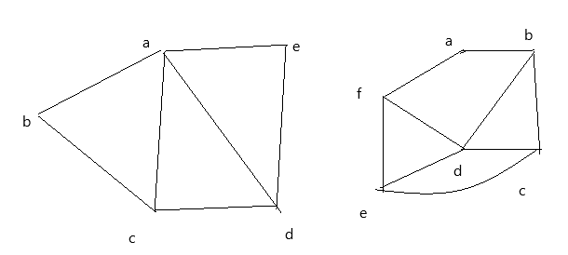 | [5M]
 | b) | What are spanning trees? Write and explain Prims algorithm.
14. | a) | Obtain principal disjunctive normal form of the following formula.  P˅(~P→(Q˅(~Q→R))) | [5M]
 | b) | Show the following equivalence without truth table.  (((P˄Q˄R)→C)˄(R→(P˅Q˅C)))⬄(R˄(P↔Q))→C | [5M]
15. | a) | Prove that the following argument is valid  ∀x p(x) →~q(x)  ¬∃x ((r(x) ˅ s(x))˄ ¬q(x)  r(a)  ∴p(a) | [5M]
 | b) | For the following formulas let the universe be R. Translate each of the following sentence into a formula (using quantifiers)  - There is a largest number  - Every positive integer has a square root (do not use square root symbol use only multiplication) | [5M]
16. | a) | Let x={1,2,3} and f, g, h be functions from x to x given by f={(1,2),(2,3),(3,1)} g={(1,2),(2,1),(3,3)} h={(1,1),(2,2),(3,1)} Find fog, foh, fohog, goh | [5M]
 | b) | Write about partial ordering and total ordering relations. | [5M]
17. |  | Write short notes on:
 | a) | automatic theorem proving. | [3M]
 | b) | Rules of Inference. | [3M]
 | c) | Homomorphism. | [4M]
18. | a) | What is pigeon hole principle? What are its applications? |  | [5M]
 | b) | Find number of positive integer solutions of x+y+z =12. |  | [5M]

-- 00 -- 00 –

SREENIDHI INSTITUTE OF SCIENCE & TECHNOLOGY
A u t o n o m o u s I n s t i t u t i o n
Yamnampet, Ghatkesar, Hyderabad – 501 301.
REGULATION: A18
FIRST MID EXAMINATION SEPTEMBER 2019
CLASS: B.Tech II YEAR I SEM Branch: CSE & IT
SUBJECT: Discrete Mathematics (DM) TIME: 1 hour 50 min
Date : 07 .09 .2019 (AN) Max Marks: 18
Part – A
(Compulsory Only Short answers) 10X ½ = 5 Marks

- a) Define a statement.
b) Is ~P^Q is Well formed formula.
- Write Modus Tollens rule
- Define Predicate.
- What is free variable? Give an example
- “This pen is blue” Symbolize the statement using predicate
- Define equivalence relation.
- What do we call Greatest Lower Bound in a lattice
- Define Monoid and give an example.
- Is G = {1,-1}under multiplication is a group or not?

Part – B
(Subjective Type Questions) 2 X 5 = 10 Marks
Answer any TWO out of the THREE questions

- With reference to automatic theorem proving , show that S∨R is tautologically implied by (P∨ Q)∧(P→R) )∧(Q→S)
3. Symbolize the following argument and check for its validity:
All men are fallible.
All kings are men.
∴ All kings are fallible
4. a) Let f : A → B, g : B → C, A = {1, 2, 3}, B = {p, q}, C = {a, b}, f = {(1, p), (2, p),
(3, q)} and g = {(p, q), (q, b)}. Find g ° f.
b) Verify whether the set G = {0, 1, 2, 3, 4, 5} is a group with respect to addition
modulo 6.

Part – C
(Assignment Questions) 1 X 3 = 3 Marks
Answer any ONE out of the THREE questions and one question must be drawn from each unit of total three units.

- Obtain the principal conjunctive normal forms of: (∼P→R) ∧ (Q↔P)
- Convert the following statements into statement formulas
a) Some students like Math’s but not Physics
b) All triangles are Isosceles
3. Draw graph and the matrix of the following relations on the set A = {1, 2, 3, 4}:
R = {(1, 1), (1, 2), (1, 3), (2, 3), (3, 3), (3, 4)}

SREENIDHI INSTITUTE OF SCIENCE & TECHNOLOGY
A u t o n o m o u s I n s t i t u t i o n
Yamnampet, Ghatkesar, Hyderabad – 501 301.
B.Tech. II Year I Sem., I Mid-Term Examinations, September -2019
Objective Exam

Branch:- CSE & IT Subject Name:- Discrete Mathematics
Date:-07/09/2019(AN)

Answer All Questions. All Questions Carry Equal Marks. Time: 10 Min. Marks: 5.

I. Choose the correct alternative: 10X ½ = 5

1 .Dual of q → p [ ]
(a)~q v p (b)~q ∧ p (c)q v ~p (d) q ∧ ~p
2. Which of the following statement is a proposition? [ ]
a) Get me a glass of milkshake b) God bless you!
c) What is the time now? d) The only odd prime number is 2
3. Negation of ∀x, F(x) [ ]
(a) ∃x, [~F(x)] (b) ∃x, F(x) (c) ∀x, [~F(x)] (d) ~[∃x, F(x)]
4. What is the Cartesian product of A = {1, 2} and B = {a, b}? [ ]
a) {(1, a), (1, b), (2, a), (b, b)} b) {(1, 1), (2, 2), (a, a), (b, b)}
c) {(1, a), (2, a), (1, b), (2, b)} d) {(1, 1), (a, a), (2, a), (1, b)}
5. Power set of empty set has exactly _________ subset. [ ]
a) One b) Two c) Zero d) Three
6. Contrapositive of p → q is -------------------------
7. Negation of (p ∧ q) v r is ---------------------------
8.”Some integers are divisible by 5”. The symbolic form is ----------------------------
9. Hasse diagram for powerset of {a,b} is
10. Given the following relations, find S o R :
R = {(1,1), (1,4), (2,3), (3,1), (3,4)}S = {(1,0),(2,0), (3,1), (3,2), (4,1)}
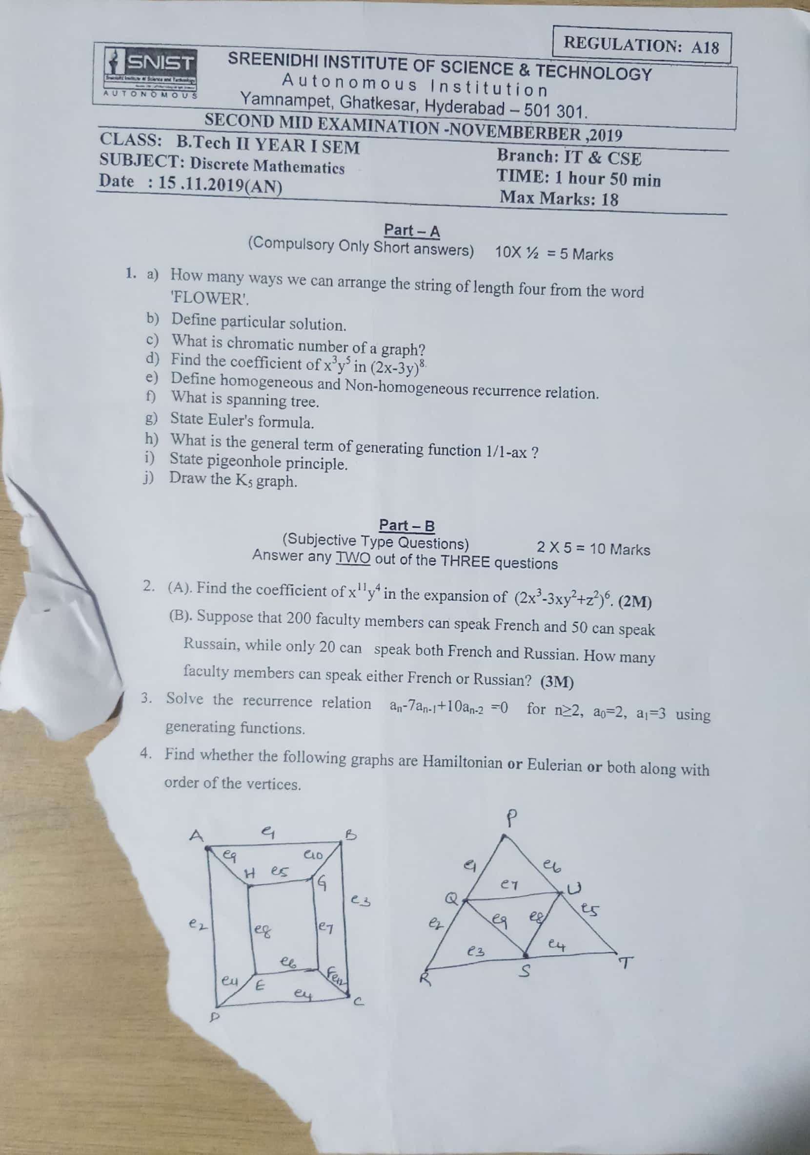

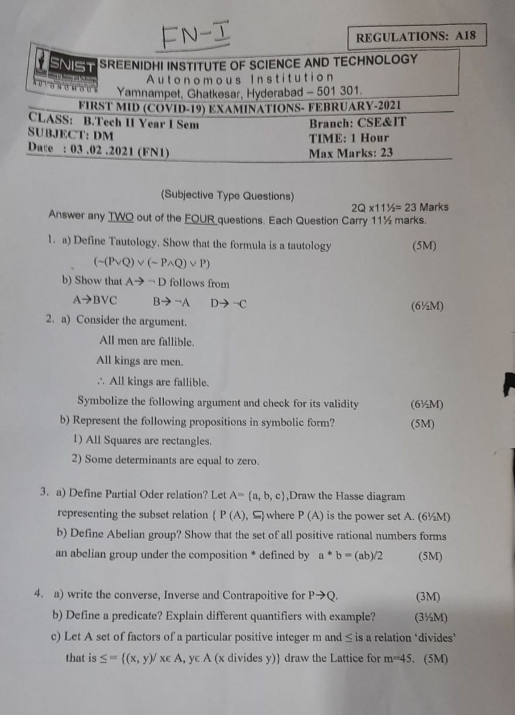

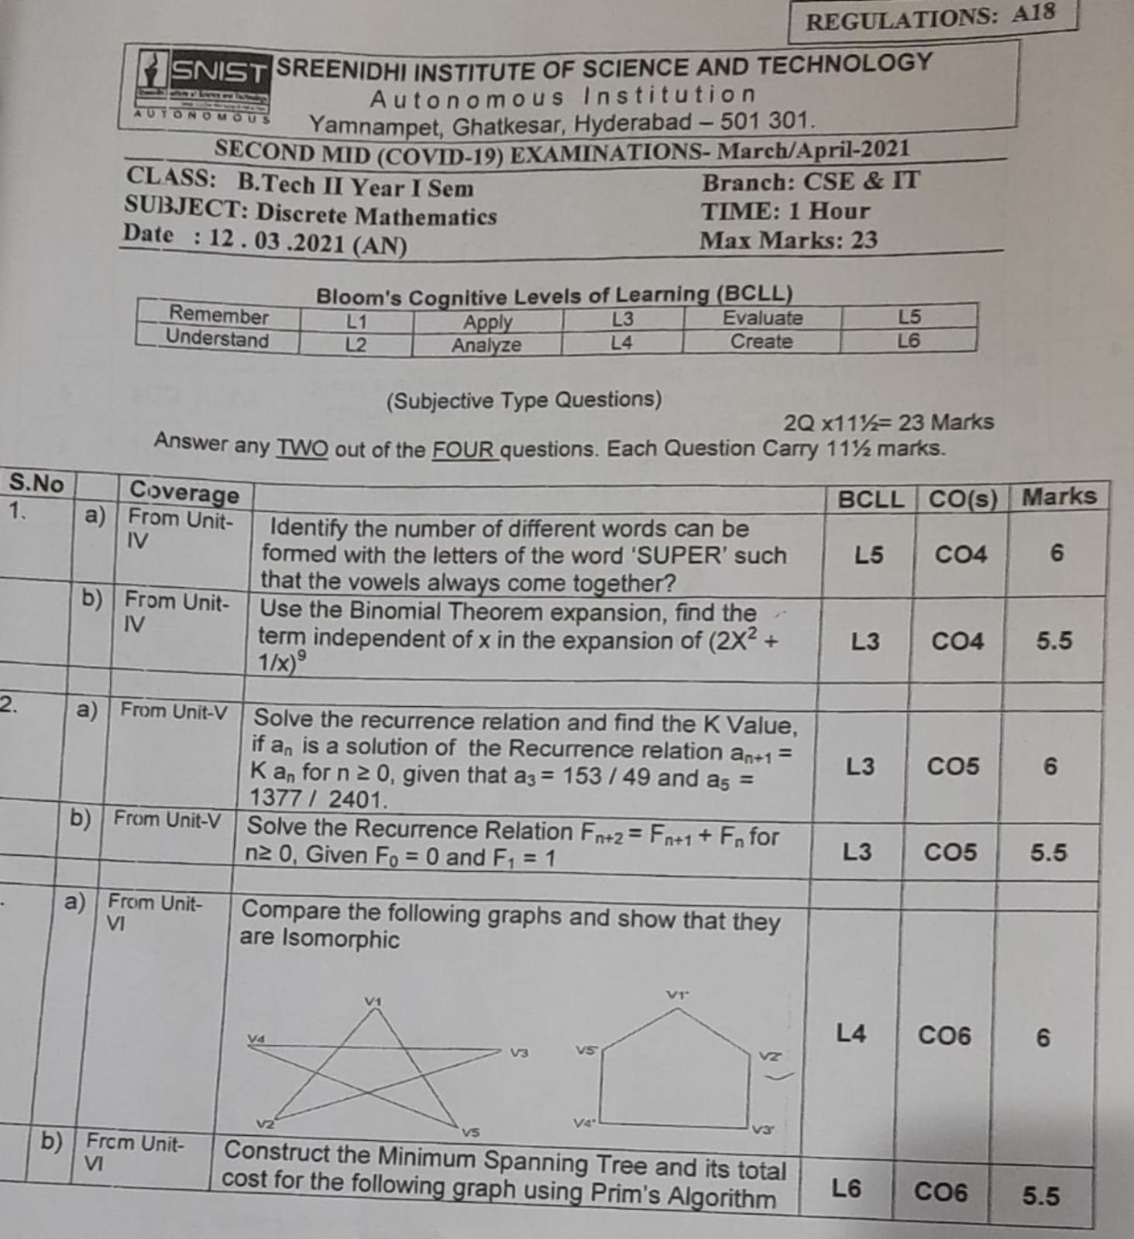

H.T No
Regulations:
A17

Sreenidhi Institute of Science and Technology
(An Autonomous Institution)
Code No: 6F302 Date: 23-Mar-2022 (FN)

B.Tech II-Year I- Semester External Examination, March/April - 2022 (Supplementary)
Mathematical Foundations of Computer Science (CSE & IT)

Time: 3 Hours Max.Marks:75

Note: a) No additional answer sheets will be provided.
b) All sub-parts of a question must be answered at one place only, otherwise it will not be valued.
c) Missing data can be assumed suitably.

ANSWER ANY 5 OUT OF 8 QUESTIONS. EACH QUESTION CARRIES 15 MARKS.

Bloom's Cognitive Levels of Learning (BCLL)

Remember | L1 | Apply | L3 | Evaluate | L5
Understand | L2 | Analyze | L4 | Create | L6

 |  |  |  | BCLL |  | CO(s) |  | Marks
1. | a) | Check whether the formula 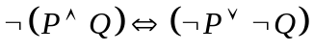 is a tautology or a contradiction. |  | L3 |  | CO1 |  | [8M]
 | b) | Obtain the principal conjunctive normal form for 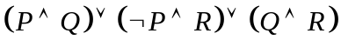 |  | L3 |  | CO1 |  | [7M]
2. | a) | Solve the recurrence relation . |  | L5 |  | CO2 |  | [8M]
 | b) | Symbolize the following statements and check for its validity:  All men are mortal, Socrates is a man, Therefore Socrates is a mortal. |  | L3 |  | CO2 |  | [7M]
3. | a) | Let R be a relation on the set 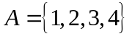defined by Check whether R is an equivalence relation or not. |  | L2 |  | CO3 |  | [8M]
 | b) | Show that 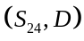 is a lattice, where 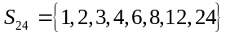and is the relation of ‘division’. |  | L2 |  | CO3 |  | [7M]
4. | a) | Check whether the set 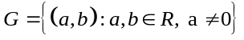under the operation defined as is an abelian group. |  | L2 |  | CO4 |  | [8M]
 | b) | State and prove Lagrange's theorem. |  | L5 |  | CO4 |  | [7M]
5. | a) | Define spanning tree of a graph G. |  | L2 |  | CO5 |  | [8M]
 | b) | Verify whether the following two graphs G1, G2 are isomorphic or not. Justify your answer.  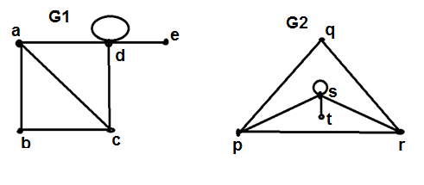 |  | L4 |  | CO5 |  | [7M]
6. | a) | Prove that a complete graph 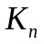 is planar iff 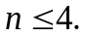 | L4 |  | CO6 |  | [8M]
 | b) | How many ways 4-digit numbers can be formed with 0,4,5,6,7,8,9, no digit being repeated. | L2 |  | CO6 |  | [7M]
7. | a) | Use indirect method to show | L4 |  | CO1 |  | [5M]
 | b) | What are free and bound variables? | L2 |  | CO2 |  | [5M]
 | c) | Prove that in a lattice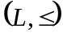, 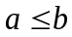 if and only if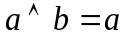. | L3 |  | CO3 |  | [5M]
8. | a) | Find P(8,4)+P(6,3). | L2 |  | CO4 |  | [5M]
 | b) | Is there a graph with degree sequence 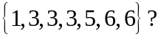 | L2 |  | CO5 |  | [5M]
 | c) | Differentiate between plannar graphs and multi graphs. | L3 |  | CO6 |  | [5M]

-- 00 -- 00 –

H.T No
Regulations:
A18

Sreenidhi Institute of Science and Technology
(An Autonomous Institution)
Code No: 7F302 Date: 12-Mar-2022(FN)

B.Tech II-Year I- Semester External Examination, March/April-2022 (Regular & Supplementary)
DISCRETE MATHEMATICS (CSE and IT)

Time: 3 Hours Max.Marks:70

Note: a) No additional answer sheets will be provided.
b) All sub-parts of a question must be answered at one place only, otherwise it will not be valued.
c) Missing data can be assumed suitably.

ANSWER ANY 5 OUT OF 8 QUESTIONS. EACH QUESTION CARRIES 14 MARKS.

Bloom's Cognitive Levels of Learning (BCLL)

Remember | L1 | Apply | L3 | Evaluate | L5
Understand | L2 | Analyze | L4 | Create | L6

 |  |  | BCLL |  | CO(s) |  | Marks
1. | a) | Test whether the following argument is valid:  If I drive to work, then I will arrive tired.  Iam not tired (when I arrive at work)  ∴ I do not drive to work | L5 |  | CO1 |  | [7M]
 | b) | Prove that R→S is a valid conclusion from the premises P→(Q→S),~R V P, and Q | L3 |  | CO1 |  | [7M]
2. | a) | Explain the term universal quantifier with an example. | L2 |  | CO2 |  | [7M]
 | b) | Prove that the following argument is valid:  All men are mortal.  Sachin is a man.  ∴ Sachin is mortal. | L3 |  | CO2 |  | [7M]
3. | a) | Let a= {1, 2, 3} and b= {2, 4, 5}. Determine the following: i) |AxB| ii) Number of relations from A to B iii) Number of binary relations on A. | L5 |  | CO3 |  | [7M]
 | b) | If N denotes the set of all natural numbers, and + and * are the usual addition and multiplication operations, show that<N,+,*> is not a ring. | L3 |  | CO3 |  | [7M]
4. | a) | State and prove Binomial theorem. | L1 |  | CO4 |  | [7M]
 | b) | Find the coefficient of xy²z²w³ in the expansion of (x+y+z+w) ⁸. | L3 |  | CO4 |  | [7M]
5. | a) | Show that f(x)=(1-x)⁻¹-x² generates the sequence 1,1,0,1,1,1… | L3 |  | CO5 |  | [7M]
 | b) | Obtain a generating function for the sequence<a_{r}>,  Where | L6 |  | CO5 |  | [7M]
6. | a) | Explain DFS algorithm. |  | L2 |  | CO6 |  |  | [7M]
 | b) | Apply a BFS algorithm to find a spanning tree  V1 v4 v6  V7  V2 v3 v5 |  | L3 |  | CO6 |  |  | [7M]
7. | a) | Find CNF of the following [~(pvq) ↔(p^q) ] |  | L6 |  | CO1 |  |  | [5M]
 | b) | Find the negation of the following quantified statement: |  | L6 |  | CO2 |  |  | [5M]
 | c) | Explain the properties of Lattice and give two examples. |  | L2 |  | CO3 |  |  | [4M]
8. | a) | Explain pigeonhole principle with example |  | L2 |  | CO4 |  |  | [5M]
 | b) | Explain Monoid using an example. |  | L2 |  | CO5 |  |  | [5M]
 | c) | What is a planar graph? Mention the properties of a planar graph. |  | L1 |  | CO6 |  |  | [4M]

-- 00 -- 00 –

H.T No
Regulations:
A20

Sreenidhi Institute of Science and Technology
(An Autonomous Institution)
Code No: 8F303 Date: 28-Feb-2022 (FN)

B.Tech II-Year I- Semester External Examination, February/March - 2022 (Regular)
DISCRETE MATHEMATICS (CSE and IT)

Time: 3 Hours Max.Marks:70

Note: a) No additional answer sheets will be provided.
b) All sub-parts of a question must be answered at one place only, otherwise it will not be valued.
c) Missing data can be assumed suitably.

ANSWER ANY 5 OUT OF 8 QUESTIONS. EACH QUESTION CARRIES 14 MARKS.

Bloom's Cognitive Levels of Learning (BCLL)

Remember | L1 | Apply | L3 | Evaluate | L5
Understand | L2 | Analyze | L4 | Create | L6

 |  |  | BCLL | CO(s) | Marks
1. | a) | Show that the predicate, [(pq) p]p is a tautology. | L3 | CO1 | [7M]
 | b) | List the connectives in propositional logic with the examples. | L1 | CO1 | [7M]
2. | a) | Show that R ٨ (P V Q) is a valid conclusion from the premises P V Q, Q → R,  P → M and ~M. | L3 | CO2 | [7M]
 | b) | Create the universal quantifier of the predicates, x is a square and x is a rectangle. | L6 | CO2 | [7M]
3. | a) | Show that the “Greater than or equal” relation is a partial ordering on the set of positive integers. | L3 | CO3 | [7M]
 | b) | Design the Hasse diagram representing the divisibility relation on set  A = {1, 2, 3, 4, 6, 12, 24}. | L4 | CO3 | [7M]
4. | a) | There are 4 oranges, 5 apples and 6 mangoes in a basket. Determine the no. of ways can a person make a selection of fruits among the fruits in the basket. | L5 | CO4 | [7M]
 | b) | Compute the number of permutations of the letters of the word ‘REMAINS’ such that the vowels always occur in odd places. | L2 | CO4 | [7M]
5. | a) | Specify the recurrence relation F_{n}= 10F_{n−1}−25F_{n−2} where F₀=3 and F₁=17 | L6 | CO5 | [7M]
 | b) | Determine the coefficient of x¹² in (x³+ x⁴ + x⁵ + x⁶ + ……)³ . | L5 | CO5 | [7M]
6. | a) | Let G be a connected planar simple graph with 35 regions, degree of each region is 6. Calculate the number of vertices in G. | L3 | CO6 | [7M]
 | b) | Is it possible for a graph with a degree 1 vertex to have an Euler circuit? Justify your answer? | L5 | CO6 | [7M]
7. | a) | Distinguish logical conjunction and logical disjunction. | L2 | CO1 | [5M]
 | b) | Write short notes on Consistency of premises with an example. | L1 | CO2 | [5M]
 | c) | Show that the relation '<' (less than) defined on N, the set of positive integers is neither an equivalence relation nor partially ordered relation. | L3 | CO3 | [4M]
8. | a) | Describe the Multinomial theorem and give an example. | L1 | CO4 | [5M]
 | b) | Solve the recurrence relation a_{n}=7a_{n-1}, where n>=1, given that a₂=98. | L3 | CO5 | [5M]
 | c) | Write short notes on coloring and Chromatic number. | L1 | CO6 | [4M]

-- 00 -- 00 –

